Narrative:
The player controls a gnome which has come to life after their owner went missing. (taken by the fungus enemies)
The gnome must go on a journey deep into the earth to find a treasure which will return gnomes owner. Using the potions left behind from one of the gnome’s previous outings.
Inspired by gnome folklore (gnomes protect their owners from evil) and fantasy gnomes (alchemists).
Pillars:
- The player should know where to go at any time but not how to get there.
- The player should never feel lost.
- The grow and shrink mechanic must be used to complete each level.
- Combat should be simple and intuitive.
Lil Gnome one Page Design Document
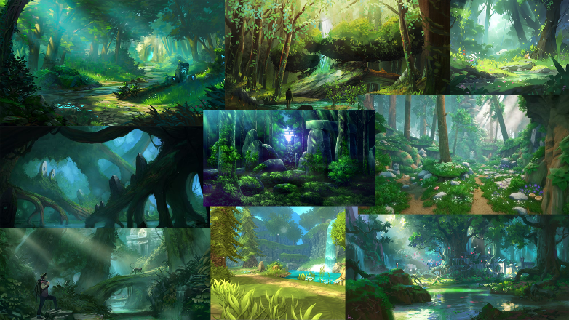
Target demographic.
Young children aged 7-12 with an interest in platformers, fantasy stories.

Mechanics:
Grown and shrink.
Dash
Fire Projectiles
Place lanterns
Double jump

Enemies:
Fungus enemy – walks towards the player.
Spider – turret, shoots web at the player.

Art Style:
The art style for this game is stylized fantasy inspired by the ori series and Alice Madness Returns.

Inspiration Mood boards:

Grow and Shrink mechanic overview:
The character has three set sizes (Small, Normal, and Big)
When big the player should be able to reach high up items/buttons and can push blocks around for puzzles.
When small the player should be able to fit into small gaps in the level to solve puzzles or climb to higher points in each “room”. The character will weigh less in this sate and will be able to use this to navigate obstacles within each level.
The player will also continuously lose health when small.

