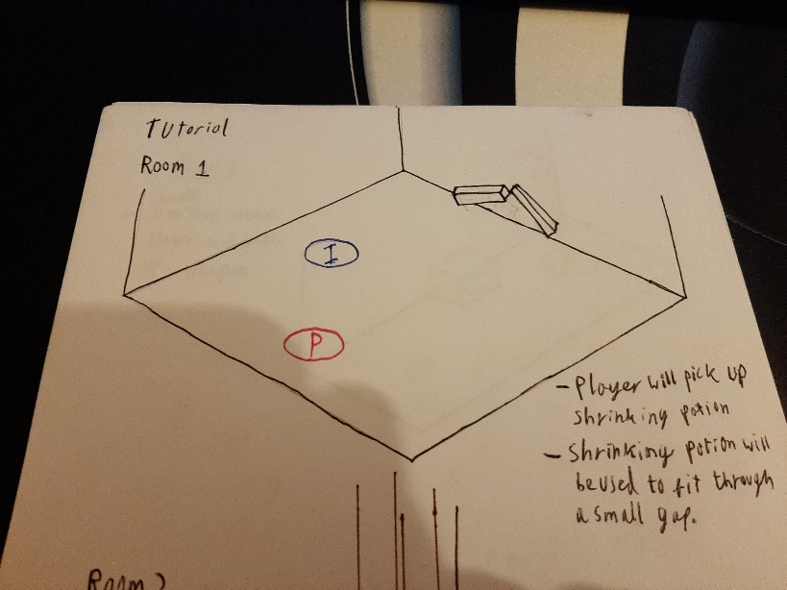
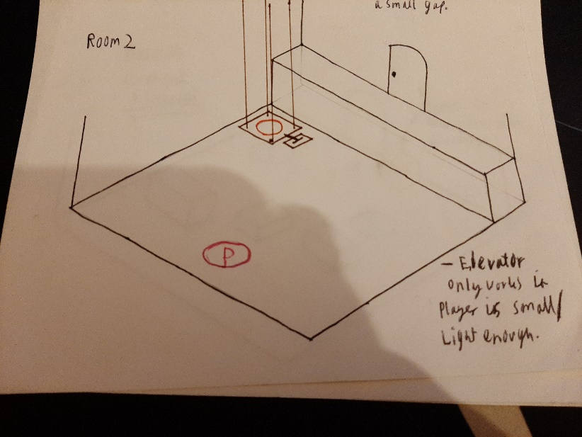
Level Design Document
This is a document containing all of the original level sketches for for Lil Gnome.
Many changes were made during development, this document briefly explains these changes.

Tutorial
The first level of the tutorial contains a pickup for the shrink potion, and an exit which is blocked unless the player uses the shrink potion to move under the gap.
Room 1

Room 2
Room two uses a lift which can only be used when the player is small due to them being too heavy in a normal or a large state.
Change:
Elevator removed, replaced with stairs.
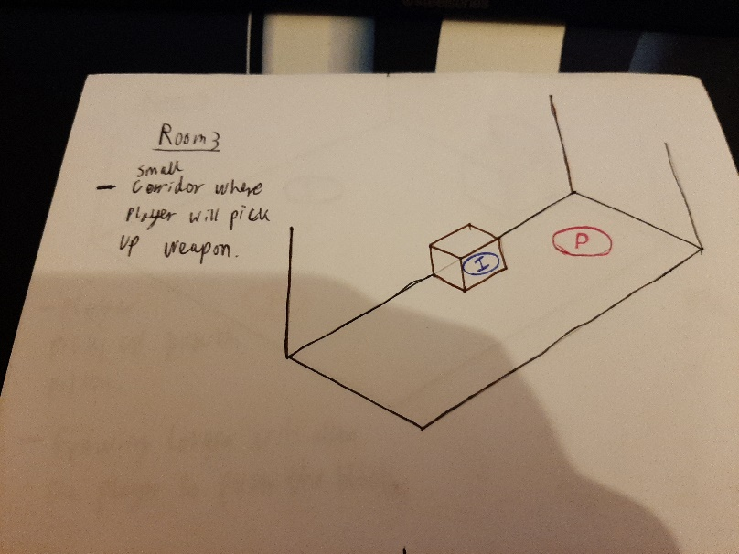
Room 3
The third “room” contains a pickup for the players weapon (a wand which shoots magic projectiles”
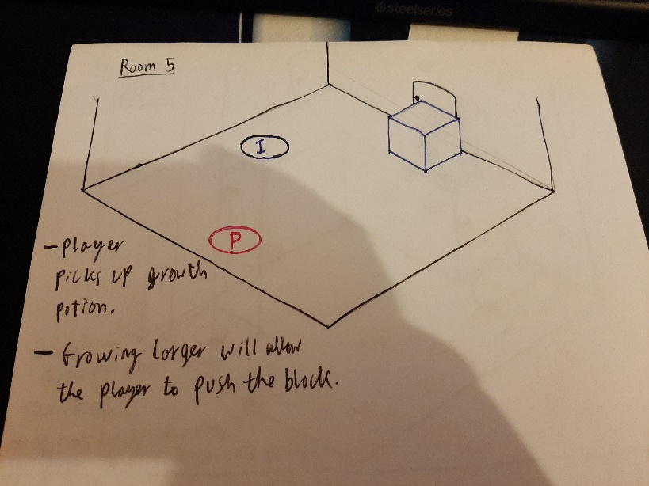
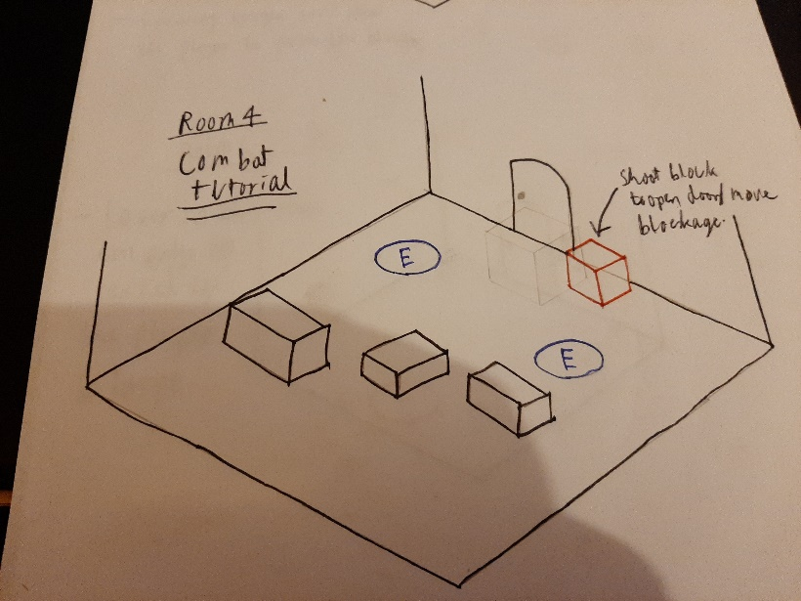
Room 5
This level will contain the pickup for the growth potion. The growth potion would allow the player to push a block out of the way and on top of a button to open the door.
Change: this section switched out for a temporary ball pickup which the player must place on a pedestal to open the door.
Room 4
This room is the combat tutorial, it contains two basic enemies which walk towards the player. Cover is placed so that the player can block the enemies path.
This room also contains a pillar which will open a door when shot.
Change:
Shootable pillar removed as players didn’t know what to do, player now uses logs to jump over a wall.
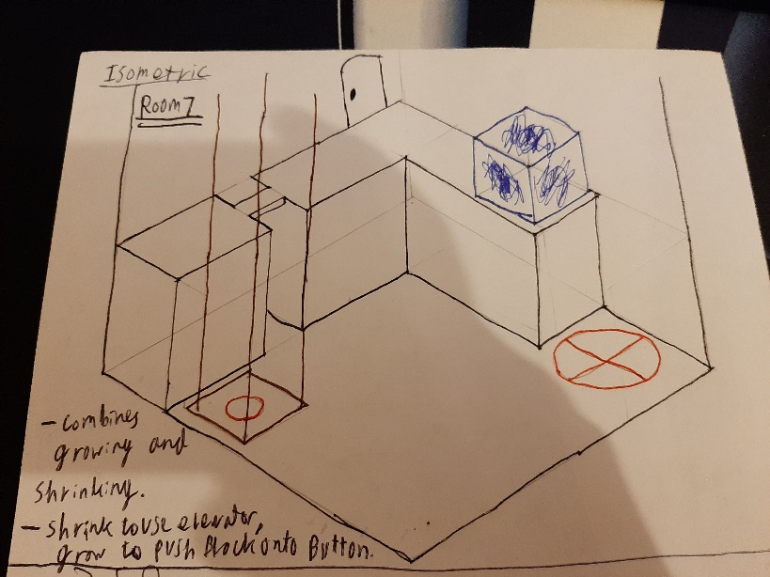
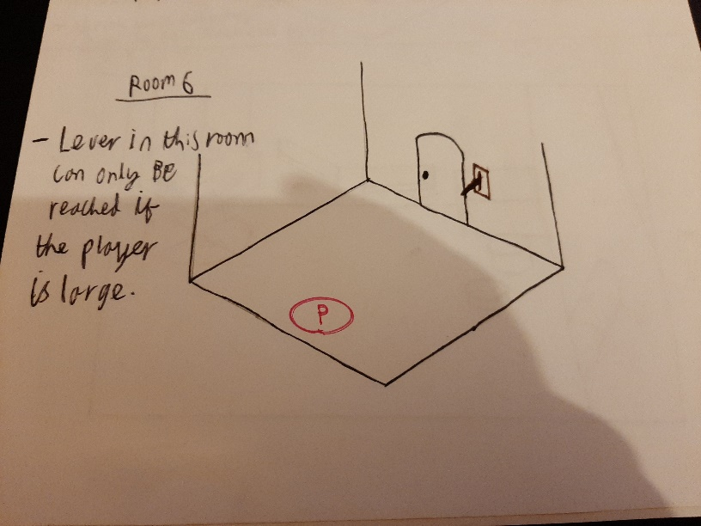
Room 6

This room contains a lever which the player can only reach if they use the growth potion.

Room 7
This level combines the shrink and grow abilities. The player must shrink to use the elevator, they then must grow large to push the block onto the button.

Change:
This area was removed due to a switch to more platformer focused gameplay.
It was replaced with a small puzzle which requires the player to shrink to enter a small passage allowing them to open a door before they enter a platforming section.

Level 1 (Forest level)
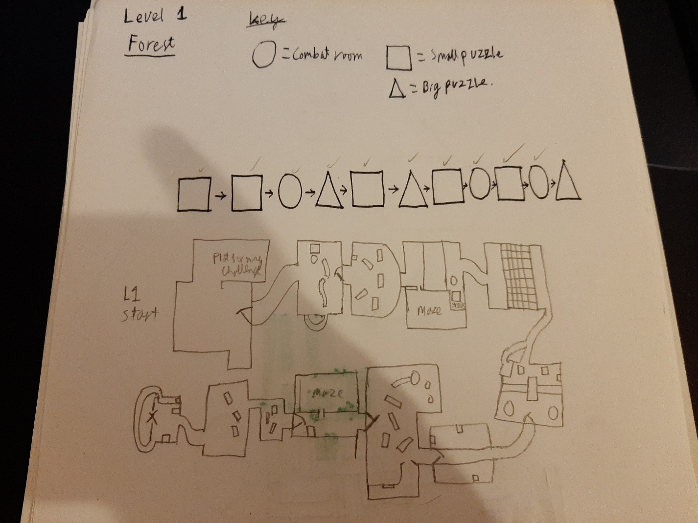
A simple flow diagram and basic top down design of the first level.

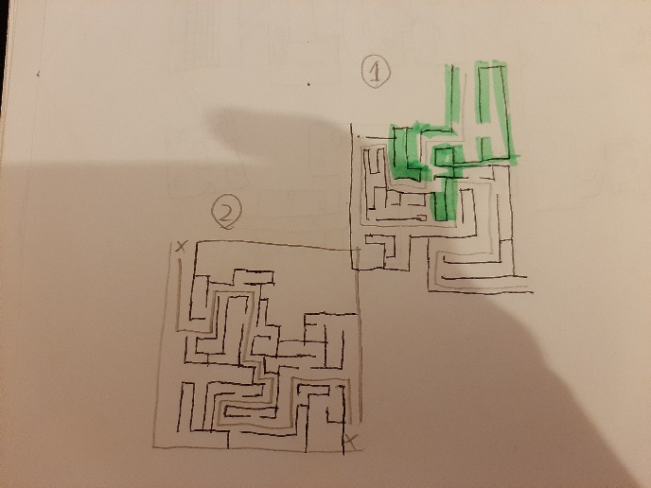
Original sketches for the maze layout.

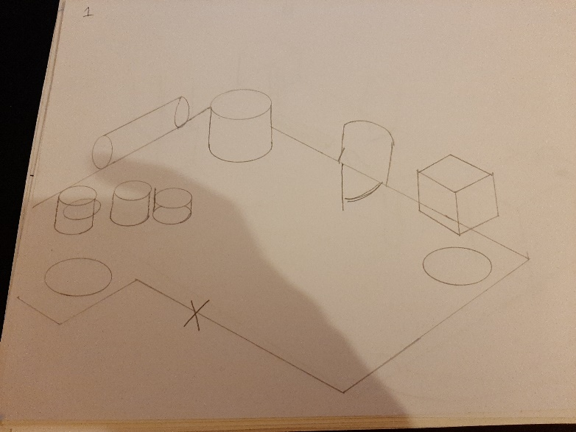
Room 1
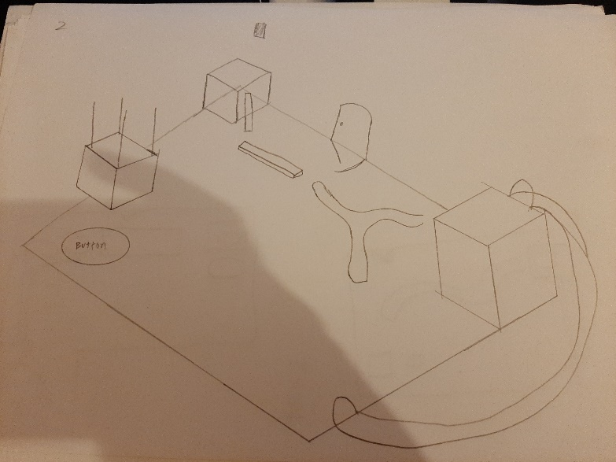
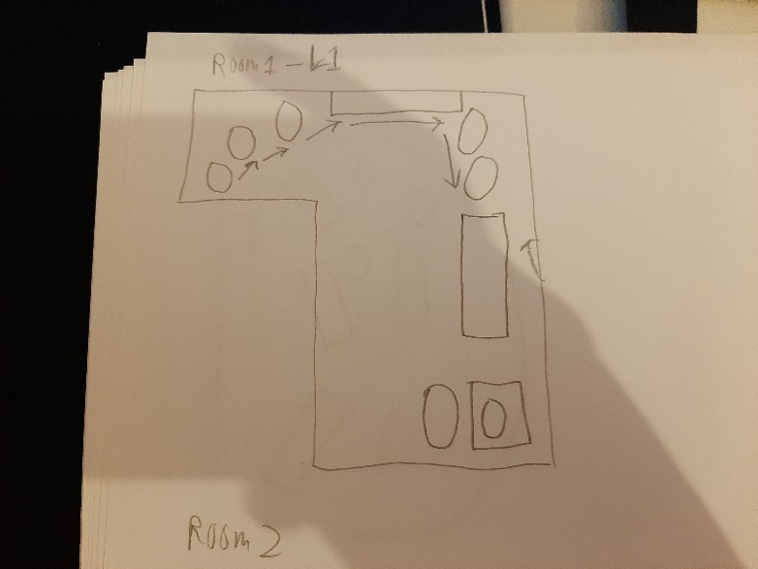
This room required the player to shrink to climb up a small passage, they will then jump across the room. And use the grow ability above the cube to make it fall.
Room 2
This room contains a platforming challenge which would require the player to become small and use the dash ability to pass to the next room.
Change:
Room layout changed.
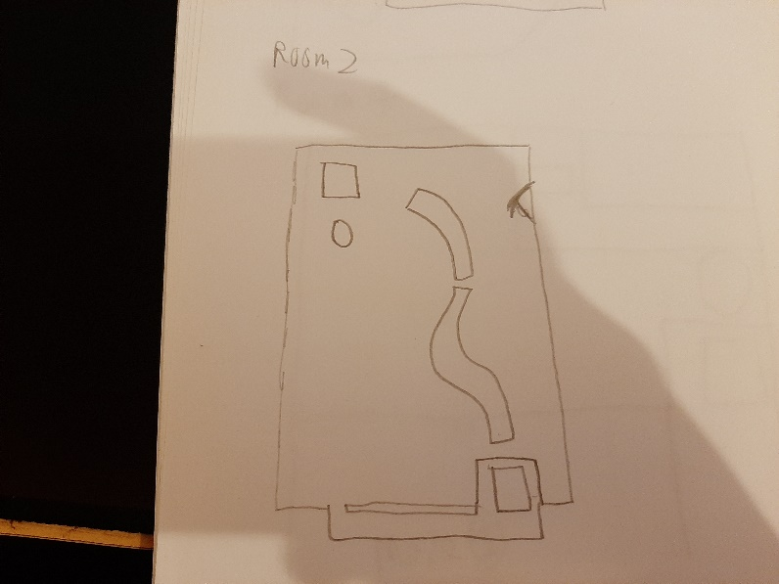
Change:
The falling block has been removed due to a switch to more platforming focused gameplay.
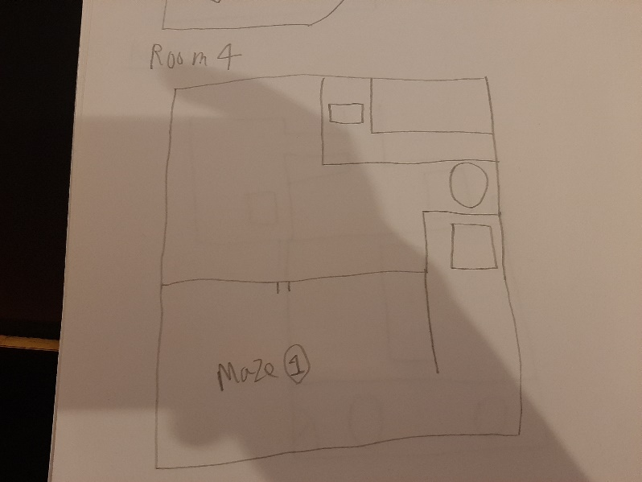
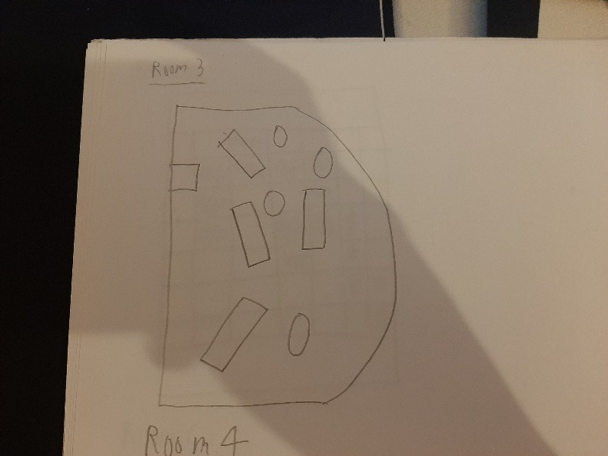
Change:
The bridge was removed. This was replaced with a raising door which falls when the button is not pressed. Forcing the player to use the dash ability to progress.
This room would have a maze the player would need to complete whilst small. This maze would provide access to a button which would raise a bridge when pressed.
Room 4
Change:
This room was removed and replaced with a simple platforming section.
This was a combat room.
Room 3
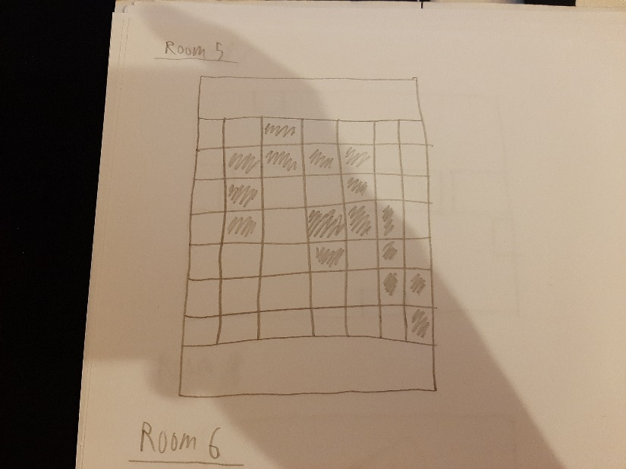
Room 5
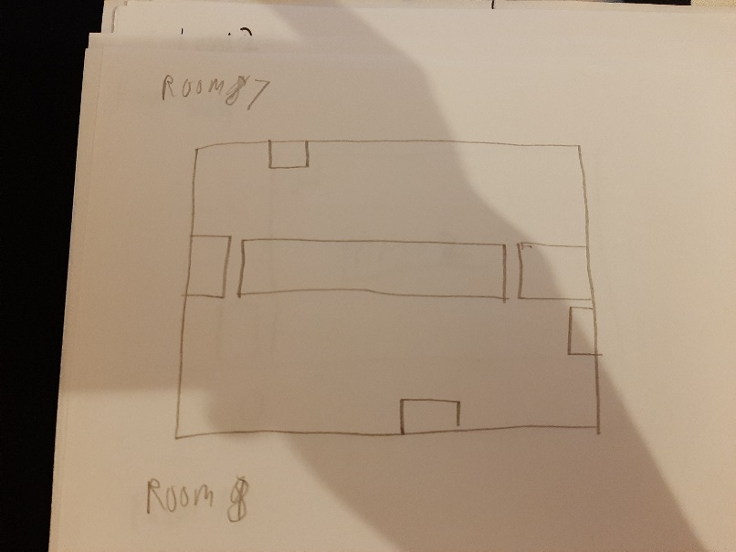
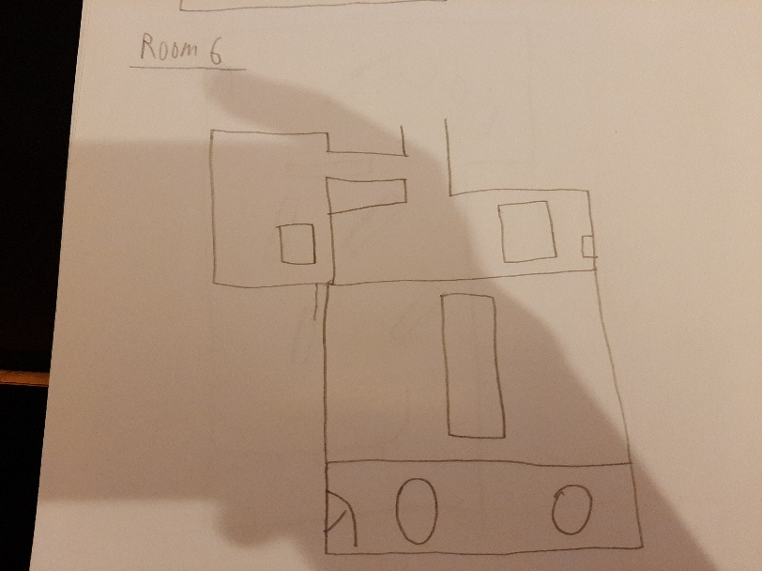
Change:
This puzzle was replaced with a large gap in the bridge which the player must combine the double jump and dash abilities to cross.
This section would have 3 shootable pillars over the sides of the bridge. When these are shot a door would open at the end.
Room 7
Change:
This puzzle was removed and replaced with a platforming section which goes through a castle. To get to the next room.
This puzzle required the player to climb on a block and use the grow ability to press a button. This will raise a bridge. The player must then push both blocks over the bridge to place on two buttons.
Room 6
This section of the level has collapsing floors. Lights would be placed above some platforms to guide the player across the non-breakable platforms.
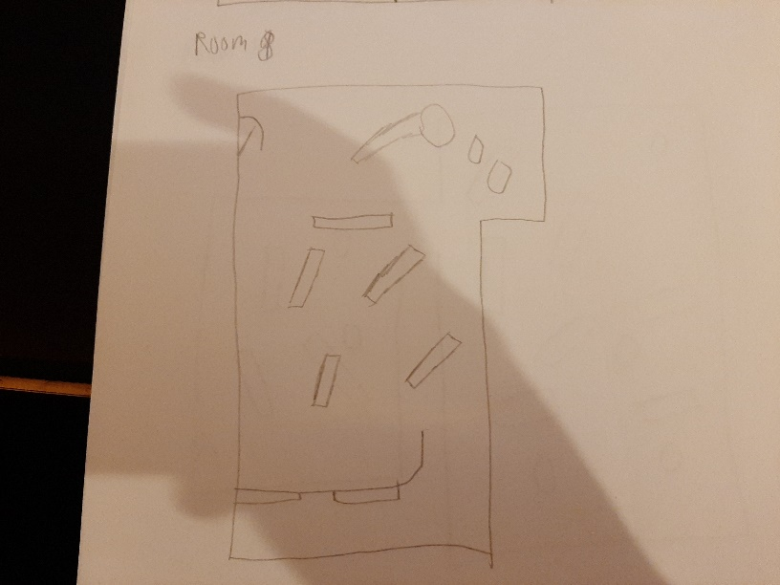
Room 8
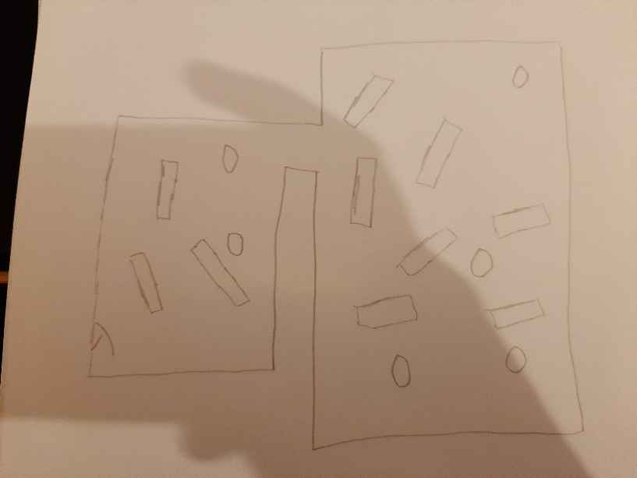
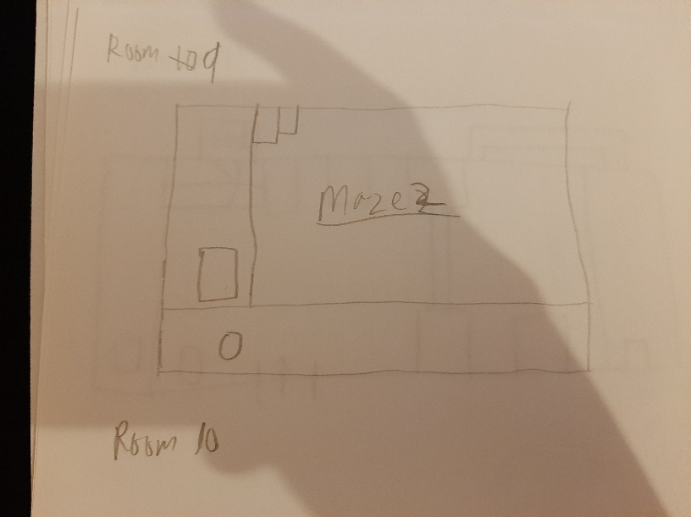
This room would require the player to complete a maze, this would allow them to use the grow ability to push the block out of the exit.
Room 9
Room 10
Change:
This room was removed from the game.
This was a combat room.
This was a combat room.
Change:
This room was removed from the game.
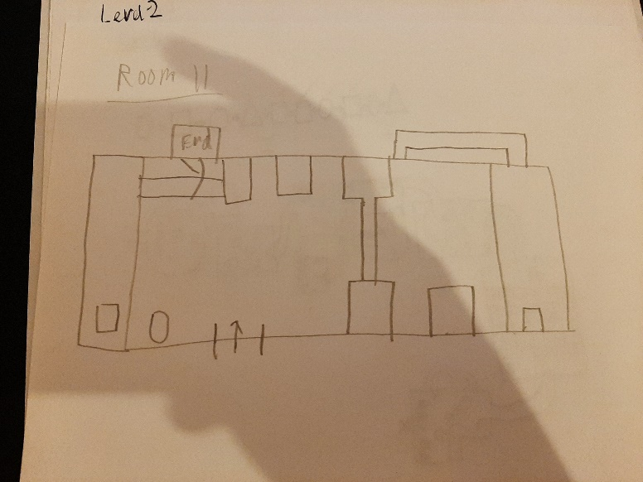
Room 11
This room is a platforming challenge which requires the player to climb up the room before they can enter the next level.

Level 2 (Cave)
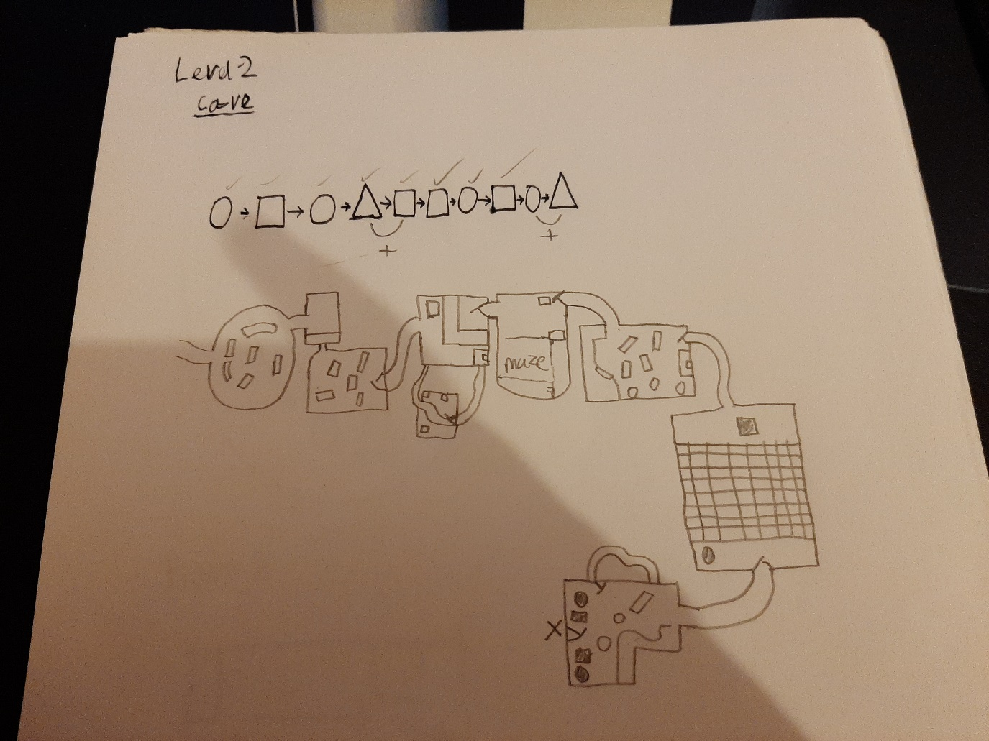
A simple flow diagram and basic top down design of the second level.

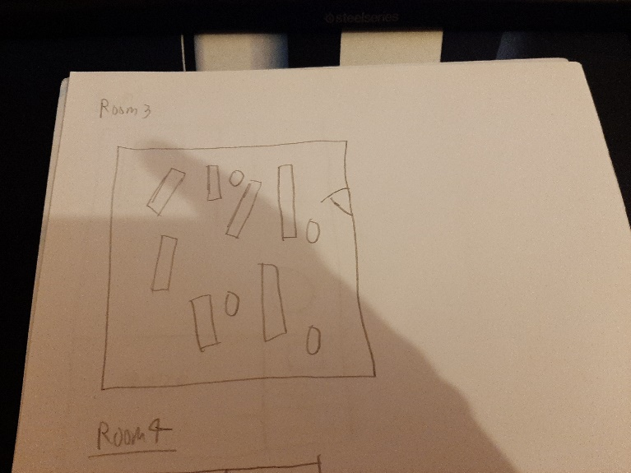
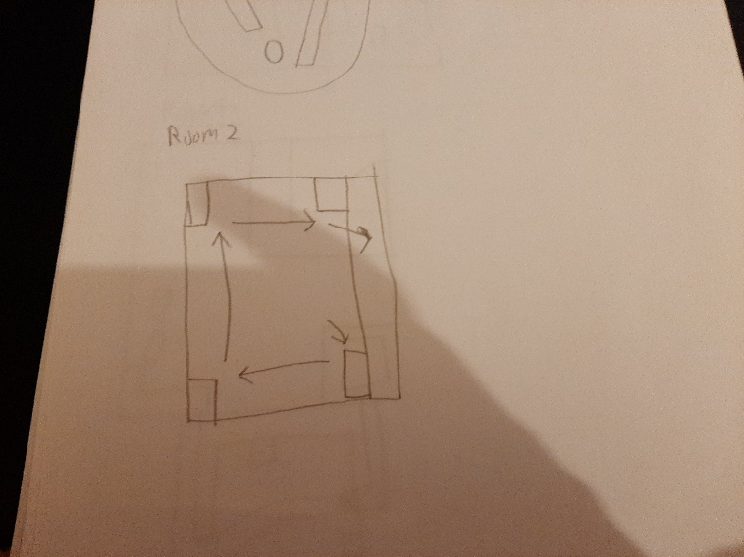
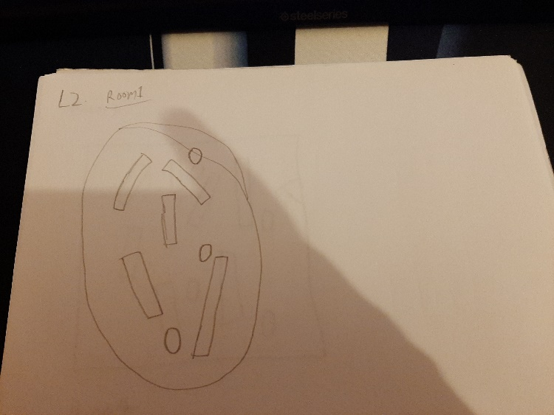
Changes:
This room was removed and replaced with a platforming section, which will kill the player if they fall.
This room would have been a combat room.
Room 3
This room required the player to jump and dash between corners to climb up to the next room.
Room 2
Changes:
This room was removed and replaced with a barrier that the player must shrink to go under, followed by an encounter with a spider enemy. (Acts like a turret)
This room would have been a combat room.
Room 1

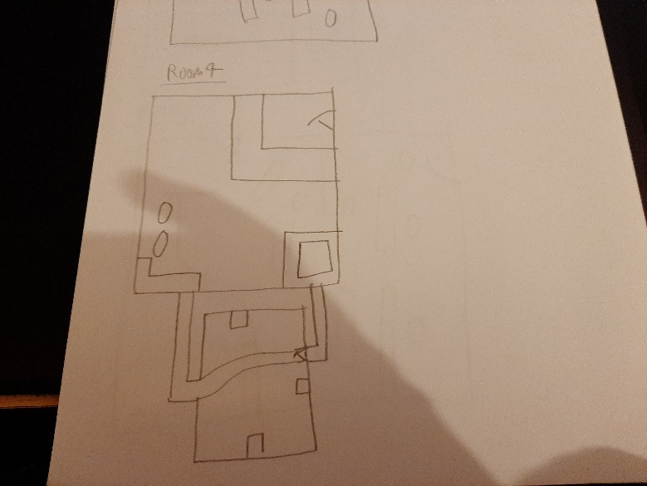
Room 4
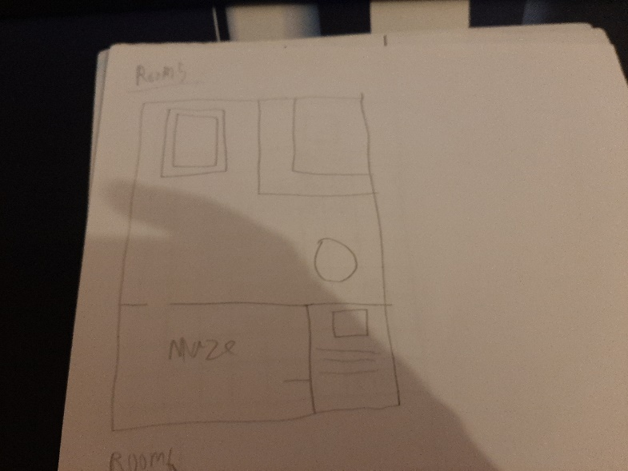
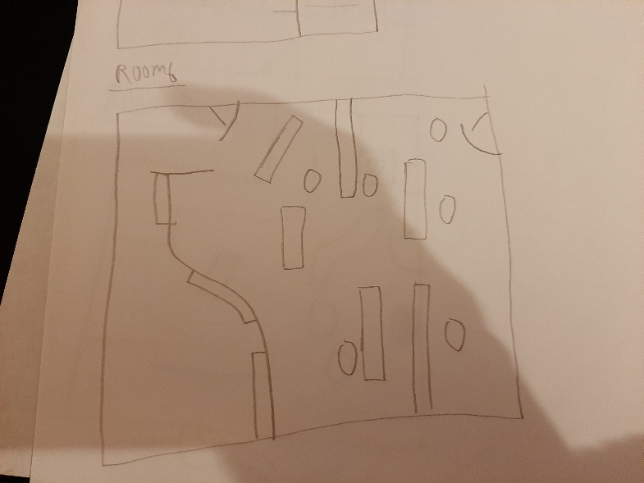
This room contains a block which is in a hole. The player would need to shrink to follow a path, and complete some combat whilst small. They will then press a button causing the block to rise which can be pushed into the gap to create a bridge.

Changes:
The combat was removed from this room, the player must now follow the path and jump to the exit.

Room 5
This room contained a maze which when completed would drop a cube to create a bridge.

Changes:
This room was changed to focus on a unique level mechanic (lanterns that can be placed) the player must complete a maze but they place lanterns to light their own way.

This room would have been a combat room.
Room 6
Changes:
This room has been replaced with platforming section. Which kills the player if they fall.

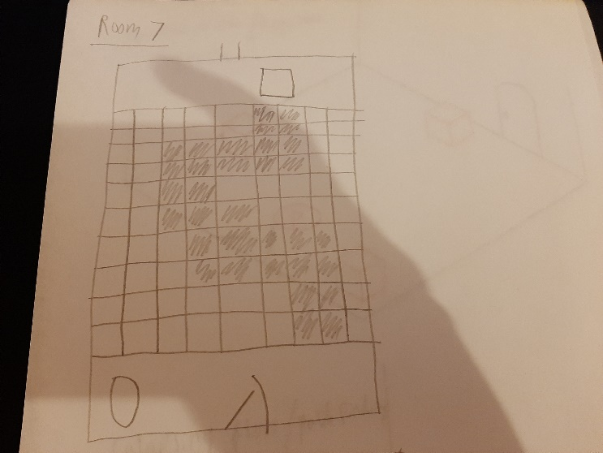
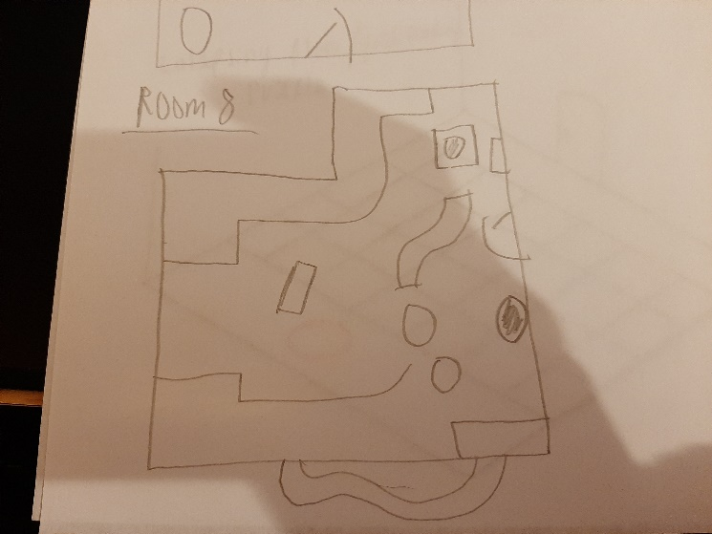
This room is a platforming section with enemies located on the floor below. Players could kill the enemies or ignore them and risk falling back into their pit.
Room 8
Changes:
This room was changed to contain the treasure chest that the player has been hunting for after the third level was cut.
This room is another collapsing floor section where the player must use the hints (Light) to successfully cross this section.
Changes:
This room had a combat section added in after it.
Room 7

Extra Sketches ideas
3 shootable pillars puzzle
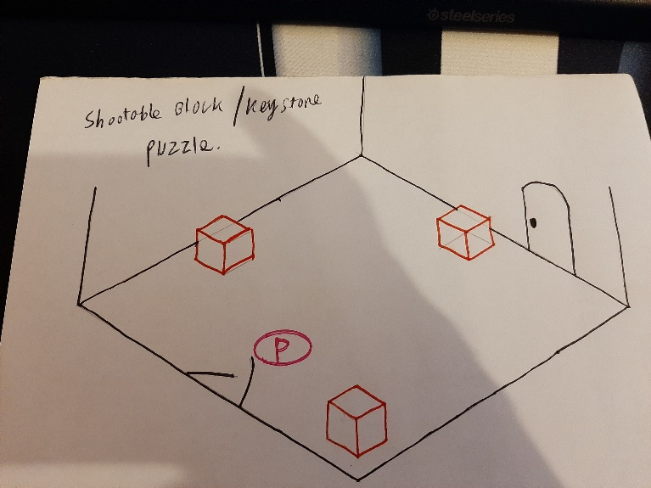
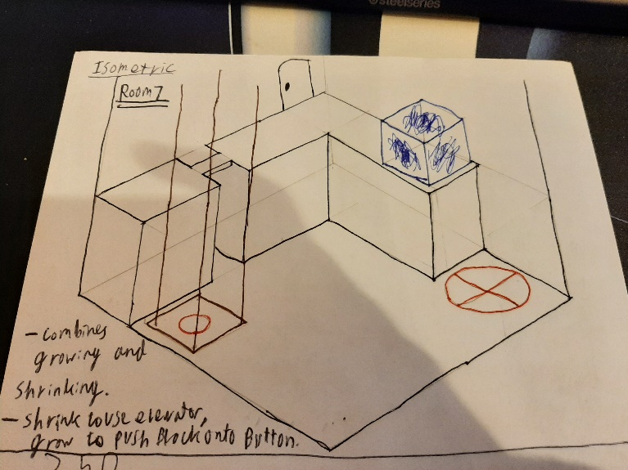
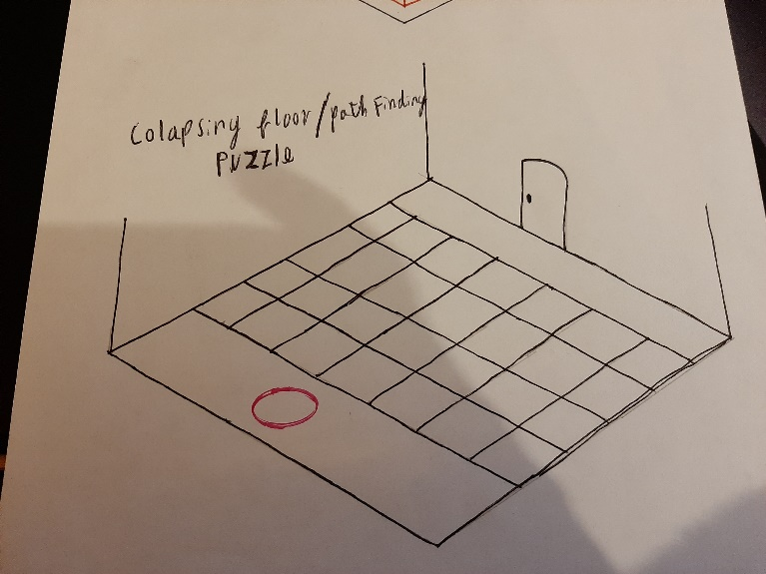
This room combined the shrink and grow ability and was originally part of the tutorial.
At one point during development the game could have been an isometric puzzle game. This level would have allowed the player to climb the wall by using the elevator before pushing the block onto the button.
This room was used in the final game. Lights located on the floor guide the player across the floor whilst avoiding falling sections of the floor.
Collapsing floor puzzle
This room would have contained three pillars which can be shot, when all three have been hit the door would be open, this would have been implemented into other levels, with the pillars being better hidden.
Room 6
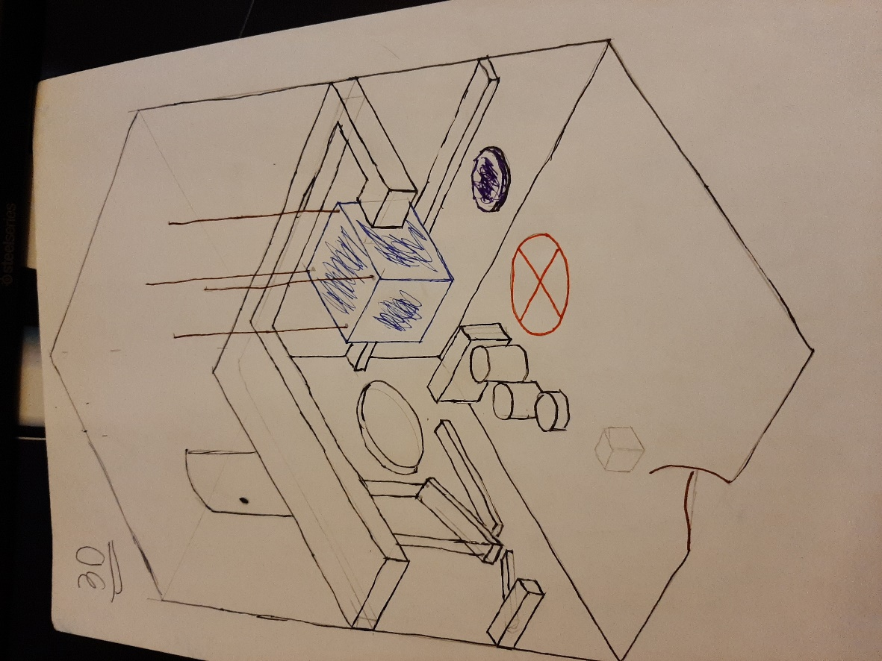
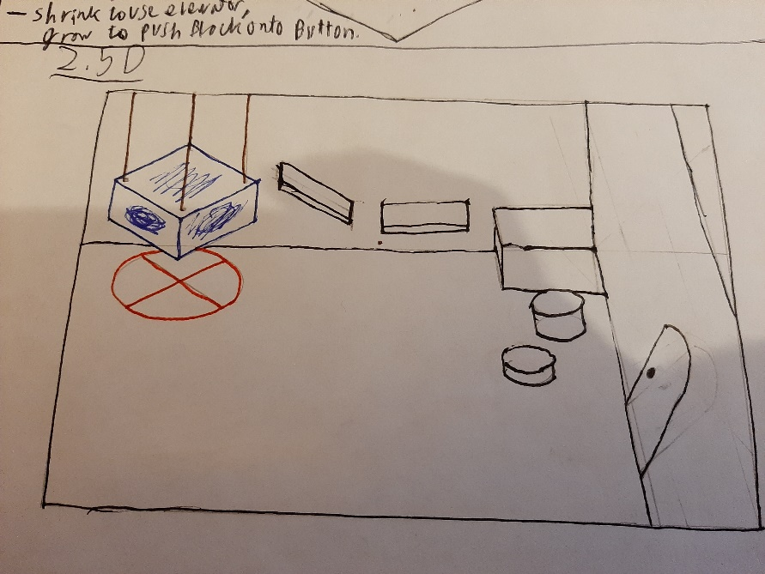
This was a room designed around the shrink ability. The player would need to shrink to climb over the small platforms on the wall. They would be able to walk around and use the purple bounce pad to reach the top of the room.
They would climb on top of the cube and use the grow ability to drop in ton the button.
The bounce pad is located next to the cube so that the player would not need to backtrack.
Potential platforming puzzle
This room was designed based on the idea of the game being a 2.5d platformer when would have allowed the player to climb and use the grow ability above the cube to snap the rope, dropping the cube onto the button.
2.5d platformer weight block puzzle

