Mother Ludlam Literature Review

Literature review word count: 3913
Contents

Table of Figures 2
Introduction 3
Myths Surrounding the Cauldron 3
Implementation of Research 3
Locations 4
Churt 4
Frensham 5
St Mary’s Church 5
Devils Jumps 5
Mother Ludlam’s Hole/Cave 6
Implementation of Research 6
Medieval Towns 6
Social structure 6
Town Structure 8
Town Guilds 8
Implementation of Research 8
15th Century Medicine 9
Medicine 9
Astrology and Medicine 10
Medicine and Religion 10
Occult Medicine 10
Life expectancy 10
Implementation of this research 10
Homosexuality in the Middle Ages 11
Implementation of This Research 11
Conclusion 11
References 13

Table of Figures

Figure 1: the cauldron in St Mary's church 4
Figure 2: Churt on a map 5
Figure 3:Mother Ludlams Cave. image 1 6
Figure 4:Mother Ludlams cave. image 2 6
Figure 5:Art depicting a 13th century French apothecary store. 7
Figure 6: A Page of the Luttrell Psalter 8
Figure 7:Illustrations of medical procedures 9
Figure 8: John Arderne's Medical Treatise 9
Figure 9: A volvelle taken from the guild-book of the barber-surgeons of York 10

Introduction
The brief dictates that a game should be created with unique cultural relevance, which will interest the player in an aspect of history, literature or folklore. Mother Ludlam (DBBJ, 2022) is based on the myth surrounding the cauldron in Frensham church (Castleton, 2020). This document will outline and display the research which has been completed, to inform the design of the Mother Ludlam game. The following topics will be discussed; research into the myth, locations, medieval life, design of medieval towns, medieval medicine and Homosexuality in the Middle Ages. This document will also explain the ways in which this research has been implemented into the Mother Ludlam game, and their relevance to its final design.

Myths Surrounding the Cauldron
St Marys Church in surrey Houses a mysterious cauldron which has been there since the Middle Ages. There are multiple myths which surround the church and its cauldron, the myths differ greatly however the cauldron and its resting place remain consistent throughout them all.
The Myth surrounding the cauldron has changed overtime, leading to there being at least three versions of the folk tale (Swancer, 2021). Likely to be the oldest version of the myth, the cauldron is said to have once belonged to the fairies which inhabited the tallest of the Devils Jumps (a set of three hills located near Churt), Stony Jump which was previously referred to as Borough Hill (Castleton, 2020). The story states that the fairies would often lend out utensils with the expectation that they would be returned within a set period of time. The individual who borrowed the cauldron returned it late leading to the fairies refusing to accept it, instead cursing the man to be followed by the cauldron. The man ended up seeking refuge St Mary’s Church. Where he passed away leaving the cauldron to remain there (Swancer, 2021).
Another version of the myth states that the cauldron once belonged to Mother Ludlam (The white witch of Farnham), who similarly to the fairies would lend things to the people residing in the local area, but with a much shorter return window of only two days. Upon realizing that her cauldron had been stolen with no intention of returning it, out of anger the witch would leave her cave causing the man to similarly seek refuge in St Mary’s Church (Topham, 2015).
A third version of the myth takes a different form, this myth states that the man who took Mother Ludlam’s cauldron was the Devil in disguise. This version of the myth has the witch chase down the devil before the cauldron was dropped atop Kettlebury hill. Mother Ludlam, concerned that the Devil would return chose to hide the cauldron in St Mary’s Church in order to protect it from The Devil (Phillips, 2020).
An Explanation of as to why this myth could have changed over time can be found in an interview by Steve Mirsky in which he talks to Julien d’Huy, an expert in evolutionary theory and Nick Matzke, an evolutionary biologist about the ways myths evolve over time and due to human migration. The interviewee explains that they studied the ways in which myths evolved using Phylogenetics (evolutionary trees), similarly to how animal evolution is studied by tracking mutations in DNA. In this interview they explain that they used a process of text analysis to understand the changes, however it can be hard to know if the differences are due to copying and modification over time or if they instead change due to varying composition by different writers (mirsky, 2016).
In Reality it is likely that the cauldron has always been the churches property. The cauldron is made of hammered copper and measures forty-eight centimetres deep with a diameter of 91 centimetres (see figure 1). The design of this cauldron implies that it was likely used for brewing the church ale for festivals and to be used as a form of income for the church (Castleton, 2020).

Implementation of Research
The designers behind Mother Ludlam (DBBJ, 2022) considered all the myths and made the decision to combine take sections of each to create a compelling story which would be a better fit for the videogame medium. This decision was reached based on the research into the ways in which Myths evolve and change overtime, and to provide a more rounded look at the mythology surrounding the cauldron in St Mary’s Church.
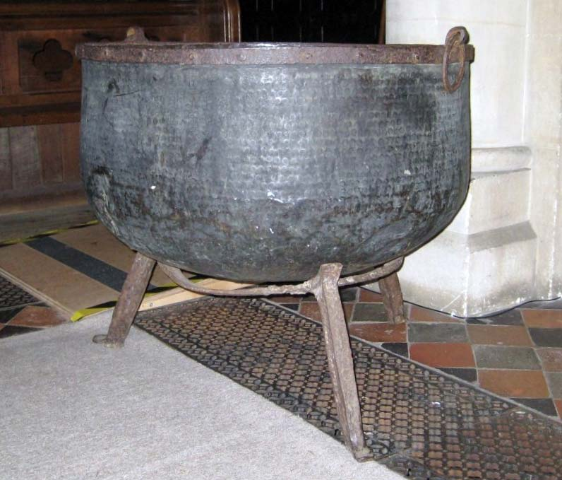
Figure 1: the cauldron in St Mary's church (Castleton, 2020).

Locations

In this section, the designers will look into the areas surrounding St Mary’s Chuch and Mother Ludlams Cave, aswell as gain some insight into the history of the surrounding areas. This section will investigate the history of Frensham, Churt, St Mary’s Church, The Devils Jumps and Mother Ludlam’s Cave.

Churt
Churt formerly known as Cert is a Town Located on the west border of Surrey which can be dated back to the 7th century when the pagan King of Wessex converted to Christianity and donated the land to the church. Cert has a history as a Farming town, with access to vast woodlands allowing the residents easy access to timber. This timber was not only used for local construction, but also for enterprise, as the roof for Westminster’s great hall was constructed near Churt before being transported to London by river (see figure 2 for map showing Churts location). In the 14th through the 16th century Churt had become a town that’s primary form of income was from farming and hop-growing, later becoming a major part of industrial Britain due to the iron industry in Surrey. (Churt Council, 2022).
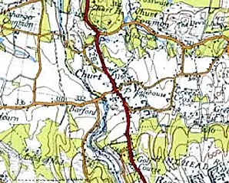
Figure 2: Churt on a map (Churt Council, 2022)

Frensham
Frensham is a town in Surrey located 4-5 miles north of Churt. This town has a long history, being tracked back to at least 3500 BC when the Neolithic People arrived using the wood from the forest to build the first houses in the area, this is known due to Archaeological research discovering their tools in the area. Around 500 BC the area is thought believed to have been inhabited by the Celts.
The name is thought to be derived from ‘Frena’s ham’. Fena being either a Danish earl who was killed in battle or saxon who was driven south by the Danes. Ham was an alternative word used for a settlement and is the origin of the word Home. Alternatively, Elfrida Manning Suggests that Fermesham a valuable holding of food rent, derived from the word Feorm, which is thought the be a word for Farm (Manning, 1970).
After the Romans and Celts left (around 400 AD) the area became inhabited by Saxons, this is known due to the discovery of Saxon weaving huts which were dated 500 AD.
In 688 AD the pagan king of Wessex, King Caedwalla converted to Christianity and Donating the land to the church. This land includes the areas of Frensham, Farnham and Churt (Churt Council, 2022) Later in 893 AD the Surrey was invaded by the Danes, but they were met by the Saxons who successfully protected their land, defeating the Danes in battle.
In 1239 St Marys Church began construction, there are also 2 ponds in the area, the great pond and the little pond. The great pond has existed at least 1200 years, the little pond however was constructed in 1246 and stocked with fish as its construction was ordered by Bishop de Ralegh.
Like most places in the United Kingdom Frensham was Heavily affected by the Black plague in 1348-1350. After this, 52 local farms were left desolate. This area was also affected by the civil war due to Farnham having a castle, in 1642 royalists imposed a tax on the people of Frensham and Churt. In 1644 Cromwell’s soldiers Raided the homes of Frensham, lacking money due to the war, they were later Billeted there in 1645 (Frensham parish Council, 2022).

St Mary’s Church
This is the church, which is mentioned in the myth, and is the location the cauldron remains to this day. The church began construction in 1239, replacing an earlier church (Frensham parish Council, 2022).

Devils Jumps
These are a collection of three hills the largest of which is called Stony Jump, they are located near Churt (Nightingale, 2020).

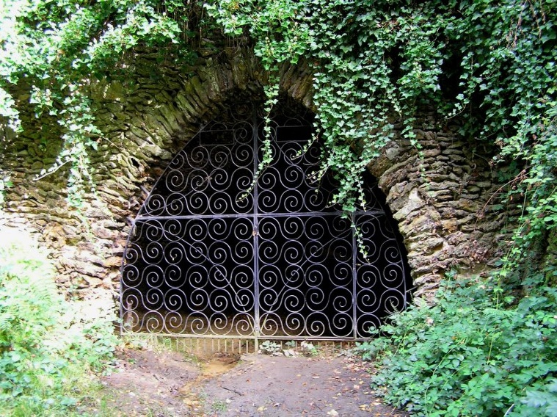
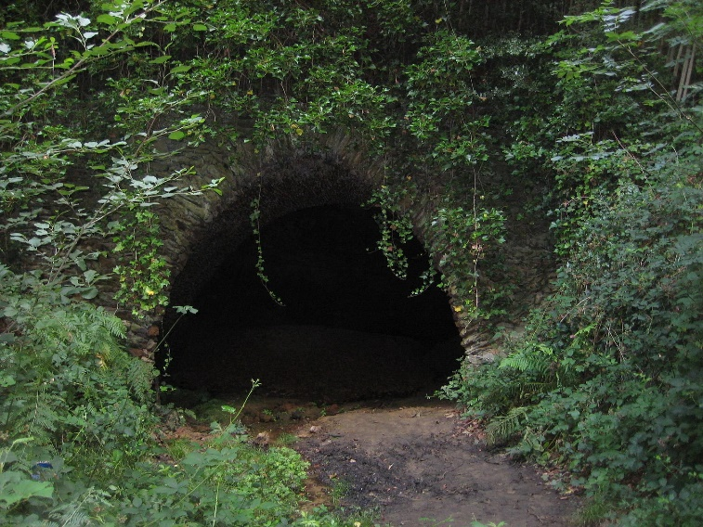
Mother Ludlam’s Hole/Cave
Figure 3:Mother Ludlams Cave. image 1 (The Great Borne Community, 2022)
Figure 4:Mother Ludlams cave. image 2 (The Great Borne Community, 2022)
Mother Ludlams Cave (see figures 3 and 4) is currently a tourist attraction in Tongham, however gained its name from the Myth of mother Ludlams Cauldron. It is said that mother luldam was a white witch who lived in this cave. People from nearby towns and villages would go to mother Ludlam to request to borrow items. In order to do this, they were required to stand on a nearby boulder and clearly state what they desire, upon returning home they would find the item on their doorstep but would have just two days to return what they borrowed (The Great Borne Community, 2022).

Implementation of Research
The Designers behind Mother Ludlam (DBBJ, 2022) have researched places relevant to the myth aswell as towns surrounding the cave. They decided Churt was the ideal setting for their Narritive as it is located within walking distance of St Mary’s Church, Mother Ludlams Cave and the Devils Jumps. Churt is also a Town with a long history, dating back to the 7th century. Between Churt and Frensham there is a lot of history to use as the basis for the educational side of their game.

Medieval Towns

Social structure
Towns in the Middle Ages contained a variety of residential and commercial structures, though often these were the same buildings. The commercial side of the property would often be located on the ground floor with the family residence on the above floors. Although intact medieval commercial structures are rare to find in modern times, art from this period can offer an insight into how these properties may have looked (see figure 5) (Bovey, 2015).
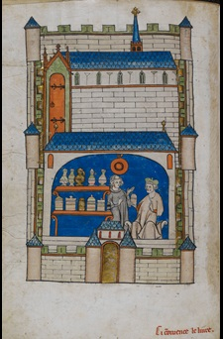
Figure 5:Art depicting a 13th century French apothecary store. (Bovey, 2015)
Just like in modern society, medieval towns had a social structure. At the top of the scale were the Lawyers, religious leaders, property owners and merchants. These people would occupy high ranking administrative positions in the town. Bellow this group of people were traders, craftsmen and unskilled labourers. Some of these people would reside within the towns but many would instead live and work on the land surrounding the town (Bovey, 2015).
Medieval houses would often reflect the social rank of the inhabitants, a person with higher social status could have a manor or small fortress with its own defences. Whereas a lower ranking person such as a craftsman would have much smaller houses, often resembling those of peasants. These were normally made of wood and would not have much space to expand. This is the reason that medieval houses often rise up multiple stories above the ground, with the ground floor being reserved for the business side of the property (Bovey, 2015).
Around the 13th century religious houses and churches became an important part of the town structure, prior to the 13th century religious leaders and Friars would often live separately to the rest of society in a monastery. It was only from the 13th century onwards that mendicant friars were introduced. Their role in society was to travel and spread the word of God, rather than living cloistered lives (Bovey, 2015).

Town Structure
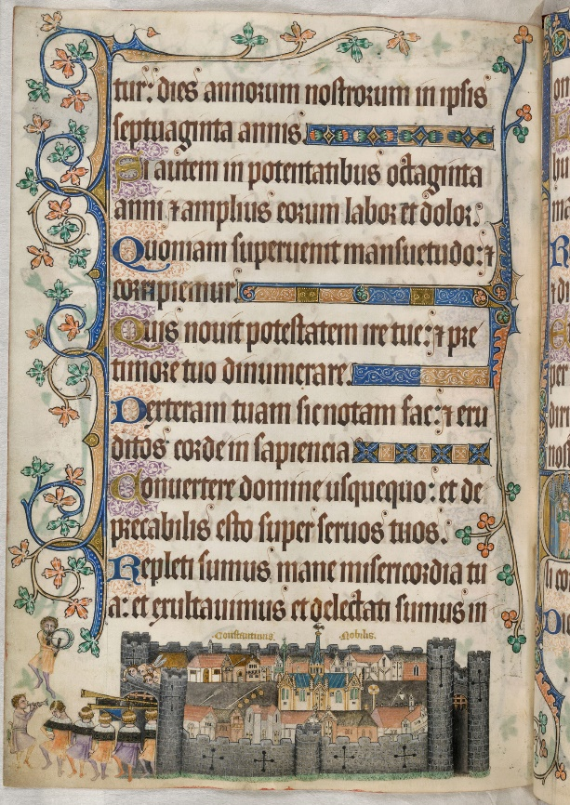
Medieval towns were often enclosed behind city walls, allowing access to these sites to be heavily regulated through the town’s gates. An illustration demonstrating this comes from the Luttrell Psalter, this image shows an English town built with the church in the centre. This town is surrounded by tall stone walls, embellished with towers and arrow slits for defence. This is shown in figure 6 (Bovey, 2015).
Figure 6: A Page of the Luttrell Psalter (Bovey, 2015)
It was common for a town to grow around an existing castle or monastery. Often these towns followed a hillside or riverbank leading to the towns having an uneven design, with streets that were meandering and of uneven width, leading to some being very narrow. Streets like this would not be functional in modern society however in the Middle Ages these towns would have had a comparatively small population, and no reason to bring horses or other vehicles into the centre of the township. The main streets would lead through the town, connecting the towns access points (Medieval Spell, 2013).

Town Guilds
Medieval guilds were collections of people who worked the same trade. These tradesmen would often be confined to conducting their business on a single street. This led to streets being named after the guilds which inhabited them, for example Tanner Street or Smith Street (Medieval Spell, 2013). Each guild also had a patron saint which were represented by the guild’s emblems, for example Saint Eloy was one of the most revered craftsmen of the seventh century, leading to him becoming the patron saint of the goldsmiths (O'Reilly, 2014).

Implementation of Research
Research into Medieval town structures and social hierarchy was important to the creators of Mother Ludlam (DBBJ, 2022) as it would influence the relationships characters have. This will also inform how the towns are Laid out. The research into mendicant friars was also vital for the inclusion of the Father John character, as Churt had no church and providing a valid reason for his inclusion in the story. The inclusion of Father John would not have been accurate to the period without this knowledge, however with his church being a central part of the myths narrative the creators felt he would be an important character to include.

15th Century Medicine

Medicine
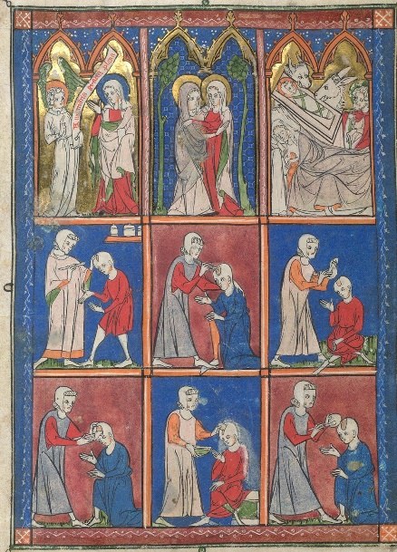
Access to medicine was limited in the Middle Ages, with most of the knowledge derived from ancient work being limited to people in monasteries, people of power and the highly educated. For the more average citizen, especially those in more rural areas, seeking medical advice from trained practitioners would have been difficult. This often led to these people taking advice derived from folklore, traditions, and personal experience (Bovey, 2015).
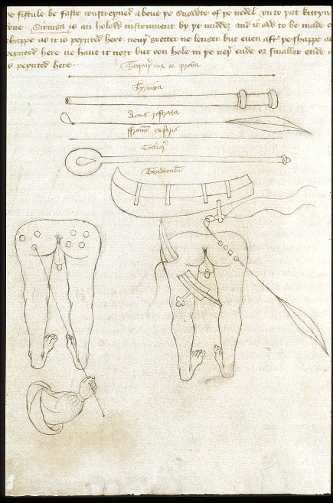
One of many areas of medical care which was necessary in this period was the treatment of ruptures and lesions. Usually, a surgeon would specialise in treating specific kinds of wounds (see figure 7). John Arderne was an English surgeon between 1307 and 1377 specialising in the treatment of eyes and anal fistula, both treatments he created were circulated around England and were widely used through the Middle Ages. His work was also written down and illustrated, allowing modern literary historians to learn about his work. An illustration of his is shown in figure 8 (Bovey, 2015). Even though it is hard to find evidence of these procedures working or the success rate, assessment of bones from this time period has provided evidence that bones had began the healing process, after surgery. This suggests that many injuries, including traumatic head injuries were not always fatal in the middle ages.
Figure 7:Illustrations of medical procedures (Bovey, 2015)
A lot of medieval ideas of medicine were derived from the ancient works of Greek Physicians such as Galen (129-216 AD) and Hippocrates. (460-370 BC) The work began by these physicians laid the groundwork for medical knowledge which would be used through to the 18th century. Their theory connects the human body to the four elements; earth, air, water and the four human humours; blood, phlegm, yellow bile, and black bile. These physicians believed that maintaining good health was possible through balancing these humours, alongside regulating diet, exercise, sleep and emotion. The section about regulating sleep, diet and exercise is supported by modern medicine however the other sections of this theory were dangerous and regularly lead physicians to advising risky procedures such as blood Letting (Bovey, 2015).
Figure 8: John Arderne's Medical Treatise (Bovey, 2015)

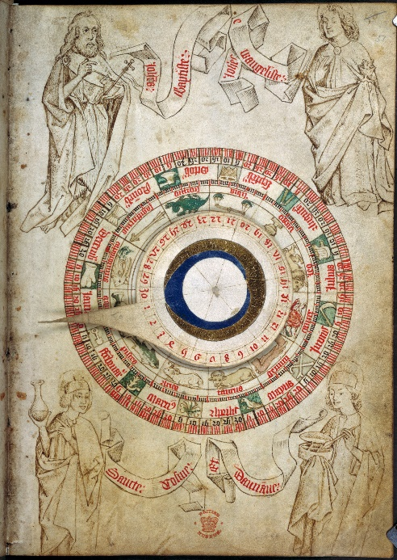
Astrology and Medicine
Figure 9: A volvelle taken from the guild-book of the barber-surgeons of York (Bovey, 2015)
Astrologers in the Middle Ages believed that the position of the stars influenced many things on earth, such as the growth of crops, personalities of newborn babies and the internal workings of the human body. Naturally, these believes made their way into the medical field. With many physicians choosing to carry a chart illustrating the positions of the stars, which they would reference when making a diagnosis (see figure 9). During the 12th and 13th century this practice became common procedure across Europe, by the end of the 15th century doctors were legally required to calculate the position of the moon prior to conducting complicated procedures such as surgery (Bovey, 2015).

Medicine and Religion
Across Europe, medical practices often worked within the confides of the Christian church, with many hospitals being operated by religious orders. Some of these were used only by members of the order, others however were used to care for the elderly. Religion was also useful when common medical treatment failed, with many people turning to the help of saints in hopes of a miracle cure for their ailment (Bovey, 2015).

Occult Medicine
The division between medicine and magic is not always clear in medieval sources with many physicians using occult information to heal the sick. Both use of natural resources such as herbs and the use of demonic magic were common ways to intervene with human health during this period (Bovey, 2015).

Life expectancy
Firs of all there is a large difference between life expectancy and life span. Life span is the actual measurement of time a person has lived, whereas life expectancy is the average lifespan of a population. This is an important differentiation to make as although looking at life expectancy can be useful when researching a specific period, it is important to remember that there will be outliers on both ends of the scale, (infant deaths and people who lived to an old age) these will skew the data. Combining this information with the high rate of infant deaths during this period, it becomes clear that much of the population would outlive the expected life span of thirty to forty years (Basaraba, 2020).

Implementation of this research
The designers behind Mother Ludlam (DBBJ, 2022) conducted this research to better understand the ways in which medieval society handled illness and injury. The information has provided them with a look into medieval society. This will influence the ways characters respond to wounds as well as provide differing views of medicine which could be looked at within cutscenes. In addition to this it has provided inspiration for accurate healing items which could be used in their game.

Homosexuality in the Middle Ages
Homosexuality was as commonplace in medieval society as it is today, however wider societal views on homosexuality has shifted over time.
Around the 15th century homosexuality was viewed as a sin in many places across Europe, this being due to the wides social influence of Christianity and the church during this period. There is also little information available relating to homosexual relations between women as the majority of literature on this subject relates only to relations between men (Halsall, 1988).
Due to the narrow views of this period, homosexuality would have been viewed as a sexual act rather romantic attraction. This view however may have been self-fulfilling as many homosexual men would feel unable to become romantically entangled with another man, choosing instead to settle into a hetro-normative society, only indulging in homosexual acts for pleasure in secret (Halsall, 1988).
Personal experiences of homosexuality during this period are hard to come by due to the persecution people would face if this information became available to others. However, there are some examples of homosexual writings. Monastic literature on love from the 12th century present some of the earliest literary evidence of homosexuality, writers such as Anselm and Aelred of Rievaulx wrote about their attraction to other men. The role sex played within these relationships is ambiguous, as it is never directly stated by the writers. The way these sources are written does communicate that their private and emotional lives were centred around men (Halsall, 1988).
Paul Halsall, lecturer at Fordham University and author of the primary document used to research this topic has expressed that the views expressed in this document do not represent his current views, and that if he was to conduct this research with his views from 2022, he would have taken a different approach.

Implementation of This Research
The team behind Mother Ludlam (DBBJ, 2022) felt that research into this area was vital for the creation of their game. This is due to the inclusion of a homosexual character within their narrative. The team wanted to portray this topic with respect but also with a sense of authenticity to the time period. The team chose to use the Halsall study (Halsall, 1988) as it primarily focuses on personal experiences of homosexuality, rather than focusing on wider societal views.

Conclusion
To conclude, this document will summarise the research and look at the ways the team behind Mother Ludlam (DBBJ, 2022) have used the information they have found.
The research into the myths surrounding the cauldron in Frensham church, provided multiple explanations for the existence of this cauldron. These explanations included fairies, Mother Ludlam and The Devil. The research also provided an explanation of the ways in which a myth can change over time. This influenced the ways in which the design team interpreted the myth and allowed a narrative to form around the information provided by the original myths.
The research into the locations surrounding Mother Ludlams Cave was vital as it provided the designers with potential setting for their narrative, as well as providing historical information about the area which can be used to educate potential players.
Town and social structures from the Middle Ages were explored. This is due to the teams need to understand the reasons towns were located where they were. The social structure is also important as it would influence the ways certain characters interact.
Research into medieval medical practices helped the team to navigate different areas of this topic as there is a lot of cross over between magic and actual medical practice. This information was useful to the designers as it provided inspiration for authentic methods of healing, which can be used in their game.
Homosexuality in the Middle Ages was a difficult topic to research as it is a subject with limited resources, due to the persecution of homosexuals during this period. The information collected however will be useful in the representation of certain characters and their interpersonal relationships.
Overall, a lot of useful information has been collected on a variety of topics central to the narrative the team decided to create. This research will allow the game to be accurate to both the source material and the time period in which it is set. However there have been some Deviation from the research, an example of this would be the destruction and abandonment of Churt. This never happened; however, this was decided upon due to the lack of material provided by the myth. Churt being chosen as the setting as it is in close proximity to both the devils jumps and Frensham.

References

Basaraba, S., 2020. verywellhealth.com. [Online]
Available at: https://www.verywellhealth.com/longevity-throughout-history-2224054
[Accessed 30 11 2022].
Bovey, A., 2015. British Library.uk. [Online]
Available at: https://www.bl.uk/the-middle-ages/articles/inside-the-walls-exploring-towns-in-the-middle-ages
[Accessed 11 11 2022].
Bovey, A., 2015. British Library.uk. [Online]
Available at: https://www.bl.uk/the-middle-ages/articles/medicine-diagnosis-and-treatment-in-the-middle-ages
[Accessed 30 11 2022].
Bullfrog Productions, 1997. Theme Hospital, Redwood City: Electronic Arts.
Castleton, D., 2020. The serpents pen. [Online]
Available at: https://www.davidcastleton.net/cauldron-frensham-church-mother-ludlams-cave/
[Accessed 4 november 2022].
Churt Council, 2022. Churt.org. [Online]
Available at: https://www.churt.org/history-of-churt
[Accessed 4 November 2022].
DBBJ, 2022. Mother Ludlam. Bolton: DBBJ.
Frensham parish Council, 2022. Frensham PC.gov. [Online]
Available at: http://www.frensham-pc.gov.uk/History_30281.aspx
[Accessed 04 11 2022].
Halsall, P., 1988. The Experience of Homosexuality in the Middle Ages. [Online]
Available at: https://sourcebooks.fordham.edu/pwh/gaymidages.asp
[Accessed 02 12 2022].
Manning, E., 1970. Saxin Farnham. Frensham: Philmore & Co Ltd.
Medieval Spell, 2013. Medieval spell, Medieval History Source. [Online]
Available at: https://www.medieval-spell.com/Medieval-Towns/#:~:text=The%20medieval%20towns%20usually%20grew,limited%2C%20the%20streets%20were%20narrow
[Accessed 08 11 2022].
mirsky, S., 2016. Scientific American - How Myths Evolve Over Time and Migrations. [Online]
Available at: https://www.scientificamerican.com/podcast/episode/how-myths-evolve-over-time-and-migrations/
[Accessed 4 November 2022].
Nightingale, L., 2020. Get Surrey. [Online]
Available at: https://www.getsurrey.co.uk/whats-on/family-kids-news/mythical-spooky-stories-behind-devils-17787277
[Accessed 4 11 2022].
O'Reilly, H., 2014. Tradition In Action .org. [Online]
Available at: https://www.traditioninaction.org/religious/f026_Saints-2.htm
[Accessed 14 11 2022].
Phillips, J., 2020. Surrey Live. [Online]
Available at: https://www.getsurrey.co.uk/news/surrey-news/infamous-borrowed-cauldron-myths-surrey-18722308
[Accessed 4 November 2022].
Schell, J., 2008. The Art of Game Design: A Book of Lenses. 1st ed. Burlington: Elsevier.
Shoebridge, C., 2020. Love The South Downs. [Online]
Available at: https://www.lovethesouthdowns.org.uk/places/the-devils-jumps
[Accessed 4 November 2022].
Swancer, B., 2021. Mysterious Universe. [Online]
Available at: https://mysteriousuniverse.org/2021/02/bizarre-stories-of-cursed-cauldrons/
[Accessed 4 november 2022].
The Great Borne Community, 2022. the Great Borne Community - Mother ludlams Cave. [Online]
Available at: https://thegreatbournecommunity.co.uk/see-do/mother-ludlams-cave
[Accessed 04 11 2022].
Topham, I., 2015. Mysterious Britain. [Online]
Available at: https://www.mysteriousbritain.co.uk/folklore/church-of-saint-mary-the-virgin-frensham/
[Accessed 4 November 2022].

Mother Ludlam Sample Scenes

Scene 1.2 (cutscene)
Scene 2.4 (Gameplay)
Scene 2.13 (Cutscene)
Scene 4.5 (Cutscene

Scene 1.2 Engine Cutscene
Robert’s farmlands, Churt
Description: Jack sees a fire burning through their crops and rushes out of the farmhouse to try and stop it. He sees figures in the flames, before Robert arrives, and the two fight the fire together.

[Camera - Camera follows beside Jack]

Jack walks tiredly through the farmhouse in the dead of night.

[Camera - The background focuses in front of a window as he startled from a glaring light]
[Camera - Camera zooms on Jack’s shocked, horrified expression, fire light brightening his face as he looks out the window]
[Camera - Camera returns to behind Jack, fixed as he runs out of frame, the fire in their fields visible through the window]

Jack (frantic): Robert! Robert, get up!

[Camera - Camera shows a wide shot outside in front of their water tank]

Jack grabs a pale of water sitting by the tank and rushes out of frame again.

[Camera - Camera shows a high shot focussing on Jack, from the fire’s POV]
[Camera - Camera shows a medium shot of Jack from the left]

Jack makes to toss the small pale, but the fire billows, consuming most of the shot from the left, making Jack flinch back dropping the pale.

[Camera - Camera Jack with a medium close up]

Jack goes to run back for more water, but stops, hearing something like a whisper under the flames’ roar

[Camera - Camera tracks in from a full body shot on Jack’s left]

Jack creeps closer to the fire, squinting into it.

[Camera - Camera catches movement in the fire, switching between close ups on flitting silhouettes]

Muffled voices and laughter rise.

[Camera - Camera shows a close up on Jack]

Jack creeps closer to the flames.

Jack (disbelieving): Who…

Robert suddenly enters the frame behind Jack, pulling his brother back by the shoulder.

[Camera - Camera switches to a wide shot from the left]

Robert hauls his pale over a significant portion of the flames

[Camera - Camera shows allow shot of Robert and Jack, the fire out of shot]

Robert (snaps): Don’t just stand there, help!
[Camera - Camera shows a medium close up on Jack]

Jack sputters as Robert rushes off to refill his pale.
Jack makes to follow, but glances back at the fire.

[Camera - Camera peds up on the empty fire]
[Camera - Camera shows a close up on Jack, tracking him slightly as he runs out of frame]

Jack shakes his head, running back to the tank.

[Camera - Camera shows a bird’s eye shot of the two brothers and the fire]

Robert and Jack work to fight the fire.

[Camera - Camera rises up to the moon]
The scene fades, the moon replaced by the sun.

Scene 2.4 - Gameplay
Moore Park
Description: This gameplay scene occurs when Robert and Thomas encounter bandits along the dirt road they are walking, wanting to steal Thomas’ lute but Robert (the player) steps in to protect him and engages combat with the bandits. To progress from this point, the player must defeat all 4 bandits without Thomas dying. There is also a broken dagger which is looted from the players after combat, required for progression.

[Camera - The camera will stay behind Robert in a 3rd person perspective as four bandits circle around the player (Robert) and Thomas shortly before dialogue begins to ensue. The player cannot move during, but they can pan the camera and do everything other than move as normal.]

Robert to Thomas (Stern yet worried): Trouble. Get behind me.
Bandit in front of Robert to Thomas (Smirking and arrogant yet confident): Well well well…. what do we have here eye boys? A little rat has brought us a lovely, sellable lute and it’s looking free…come on then? Hand it over or else you and your buddy here aren’t making it out of here alive and we’ll just take it anyway!
Robert (Staring at the Bandit, gripping his bow and taking his stance): You won’t be getting out of here so easily if you dare try.
Bandit in front, to Robert (Laughing now and drawing his dagger): Looks like we got a wannabe hero. Why don’t you just try to stop all four of us, your pathetic friend there ain’t going to be helping you! The bandit then bursts into laughter before stepping closer

Control is then handed back to the player as the HUD display and Ui returns, combat now ensuing as the player engages combat with the four bandits circling the player and Thomas. This combat scene is non-linear and therefore different dialogue options are triggered by if statements depending on the outcome.

If player dies fighting the bandits:
[Camera - The camera pants overhead of the player’s body after they die before slowly zooming out further and further out, the screen darkening as Robert quietly speaks, drawing his last breath before the player is met with a “load last checkpoint “screen.]
Robert (weak, drawing shallow breaths): No way I failed…the people…they’re depending on me…….no…

If Thomas dies during the combat section:
[Camera - The camera quickly moves to Thomas dropping to the floor as he dies, as Robert speaks to him as the screen fades out to “load last checkpoint screen “]
Robert (In distress and enraged): NO!! THOMAS!! IT’S OKAY, YOU’RE GONNA BE OKAY... (Quieter and more upset now): No…It can’t end like this Thomas….

If Robert defeats all four bandits and Thomas survives:
Thomas runs quickly up to the player as he cries and speaks, the player is free to explore around the site as Thomas speaks but will find nothing of interest other than the bandit bodies on the ground until the prompt to loot the dagger.

Thomas (Crying and sniffling into Roberts’ shoulder): Y-You did it!!! I can’t believe you defeated them all…you truly are amazing…thank you so so much Robert, truly…
Robert (A small smile as he speaks reassuringly) I’d protect my precious friends from any threat, even the witch if God had willed it so. Rest easy knowing we’re both going to make it out of this ordeal and enjoy some lovely drinks together back at the tavern, friend.
Thomas (Clearly shaken up and still crying, slower now): Thomas, you should take that broken dagger on the bandit, I’m sure we could get it fixed back at town with ease and it’s sure to help us survive, I can’t imagine fighting with the bow and sling was easy in such close range.
The player is then directed towards the body of the bandit where they may interact to loot the dagger from the body. If picked up, the player character picks up the dagger and puts it into their bag before speaking once again to Thomas.
Robert (Confidently with a smile): Let’s carry on our journey, shall we? I don’t know about you Thomas, but I’m just about tired of dirt roads for a while.
Thomas (Collecting himself now and in a bit of a timid tone): Yes, me too Robert. Gosh, me too…
The player (still in control) is directed towards the dirt road whereas they walk, Thomas will quickly catch up and walk steadily beside them as the scene comes to a close.

Scene 2.13 (Cutscene)
Description: after Robert and Thomas complete the puzzle the fairies laugh at them and after a conversation the fairies refuse to take back the cauldron. Robert gives up and wants to take the cauldron back to Mother Ludlam.

[Camera - After Robert and Thomas complete the puzzle, the camera switches to close up of the face of the fairy queen]
Fairy queen: (while laughing) wow you’re slow, our children could beat that time in less time than you. I knew that you were an inferior race but blimy, I didn’t know you were so stupid.
[Camera - The camera switches to Robert and Thomas].
Robert: (frustrated) ok, but we still beat it though, we did our part of the deal, now it’s your turn, take the cauldron.
[Camera zooms out revealing all the characters from the side].
Fairy Queen: (chuckles) You really thought I would take the cauldron off you, you vermin really are slow, there was no deal, I was never going to take back the cauldron, I just wanted to see you humiliated for my own enjoyment.
[Camera - the camera switches to a close up of the face of the queen and lets out a big laugh as well as lower fairies. Robert and Thomas look defeated and Robert gets down on his knees].
[Camera - the camera switches to Robert from the height of the fairy queen looking down on Robert]
Robert: (now scared) Please! we need you to take the cauldron, there’s a witch hunting us down because we stole the cauldron.
[Camera - camera moves left.]
Thomas: if you don’t, she will kill us. come on, we risked our neck to trick her into letting us borrow her cauldron, just for you.
[Camera - camera switches to the point where Robert is looking up at the fairy queen]
Fairy Queen: (with a sarcastic tone) aww you did that for little old me, how foolish you should have just returned the cauldron to the witch on time.
[Camera - the camera zooms in on the fairy queens face and now the queen has a serious look on her face].
Fairy Queen: you don’t know how doomed you really are, I’ve known the witch for a quite a while, we could even be considered friends at a time. Her power is his immeasurable when compared to humans, she will hunt you down and she will kill you. Now get out of my sight, I don’t want your dirty human blood ruining my land when she comes.
[Camera - the camera follows the fairies as they enter the well she came from, leaving Robert and Thomas a final snarky remark].
Fairy Queen: (snarky tone) Good luck.
[Camera - she and the fairies disappear into the well and then the camera switches back to Robert and Thomas].
Thomas: (sarcastic) well that went well, what now?
Robert: (sad and ashamed tone) How stupid I was, why did I think the fairies would help us? they only care about themselves
Thomas: (trying to reassure) come on Robert don’t beat yourself up about it, I thought they would help too, they had us both fooled
Robert: (wiping his tears and stands up) you’re right and I know what we need to do, we must return the cauldron to the witch.

Act 4 scene 5 cutscene “Beginning of our end”
Description: The scene will show Robert eating with the surviving Townspeople, the townspeople are angry that Robert because his reckless decision brought death to their doorstep. Robert still cares for the townspeople and wants to ensure they are safe from now on.
[Camera - The scene opens with a close up shot of the rabbit Robert killed in the last scene.]
[Camera – The camera pulls back to show Robert still holding the rabbit.]
Robert places the Rabbit carcass on a rock, and pulls out his dagger. He then looks down at the rabbit with a hint of regret in his eyes. Robert then looks into the distance over his shoulder over his shoulder.
[Camera – the camera pulls up slightly showing Churt burning down in the distance, Robert’s shadow hangs over the image of the village, on the side of the frame the fire they are now using to cook is obscuring the rest of the survivors.]
Robert looks back down to the rabbit carcass and places the dagger down next to it. He then begins to walk over too the rest of the survivors.
[camera – The camera switches to a medium shot showing the surviving townspeople sat on one side of the fire whilst Robert approaches from the other]
Robert: I jus-
[camera – The camera switches to a close up shot of Eleanor’s face]
Eleanor (furious at Robert): Stay back you swine!
[camera – switches back to the previous medium shot]
Thomas gets up in a rush and stands between Eleanor and Robert.
Thomas (defensive): leave him alone Eleanor, he only did what he thought was right!
[Camera – switch to a medium shot showing a front on view of Thomas with Robert behind his shoulder]
Robert places his hand on Thomas’s shoulder.
Robert (calmly): it’s okay, let her speak her mind.
[Camera – switches to medium shot showing them all sat down]
[Camera – switches to a close up of Eleanor]
Eleanor (furious): I don’t need you to tell me what I can and can’t do Robert. Your reckless decision brought death to our door.
[Camera – switches to a close up shot of Thomas]
Thomas: We all lost someone close to us, even Robert.
[camera – close up of Eleanor’s face]
Eleanor now physically shaking with anger, she screams and begins to cry.
Eleanor (beginning to get frustrated with Thomas): William’s gone and it’s all his fault!
[camera – close up of Thomas’s face]
Thomas (also beginning to get frustrated): Leofwine’s dead too, don’t you think Roberts hurting just as much.
[Camera – switches back to a medium shot showing their silhouettes with the fire behind them]
Eleanor: he is. But Robert doesn’t even seem to care
Thomas: of course, he doe-
[Camera – cuts to a close up of Eleanor’s face]
Eleanor (cutting Thomas off): I know he cares! But he should have listened to me. This is all his fault; everything was fine before.
[Camera – medium shot of Eleanor sat down from a side angle]
Eleanor(Upset): if he had just listened to me, none of this would have happened
Crying can be heard coming from off screen
[camera – the camera turns and zooms in on Jack]
Jack (through tears): Its not his fault its mine.
Robert approaches jack and places a hand on his shoulder.
[Camera – Switches to a medium shot showing Thomas sat down from a front facing angle, with Robert behind]
Robert(attempting to comfort Jack): your idea was the best one we had, and its not like you knew taking the cauldron home would cause this
[camera – switches to a medium shot of Eleanor who is now waving her arms to emphasise what she is saying]
Eleanor(confused and annoyed): This was Jacks idea? Why would you trust jack! All he does is cause problems for the rest of us.
Robert turns to face Eleanor
[camera - switches to a medium shot of Robert and Eleanor, showing the space between then (the distance between them is further now than in previous shots)]
Robert(defensive): Leave Jack out of this!
Robert kneels next to jack
[Camera – switches back to medium shot of Thomas with Robert crouched next to him]
Robert(comforting): This isn’t your fault Jack, we all made mistakes. But now we need to keep moving forward
Jack looks up at Robert
Jack (through tears): But how?
Robert (Comforting): I don’t know yet, but I believe you will figure this out. Remember what we talked about when we were hunting?
[camera – switches to a close up of jacks face]
Jack(concerned): Yes, but I do not see how that’s relev-
[camera- camera snaps to a close up of Roberts face as he cuts Jack off]
Robert(confident): These people need you jack. Make sure they get to Franham safely, me and Thomas still need to put things right
[Camera – switches back to a close up of Jacks face]
Jack (Angry and Worried): Don’t leave me Robert, I can’t do this alone
[Camera – switches back to a medium shot from a front facing angle]
Robert once again places his hand on Jacks shoulder as a comfort
[camera – switches to a wide shot focusing on the back of Robert and Jack with Eleanor and Thomas over to the side]
Robert stands and begins to back towards the Rabbit carcass (Now facing the camera
Robert looks over his shoulder
[camera – switches to a close up shot of Roberts face]
Robert(Confident and comforting): I believe in you Jack
Robert picks up the rabbit carcass and looks at it
[Camera – close shot of Robert looking the rabbit in the eyes from a side angle]
Robert (with a hint of regret in his voice): I guess you’re not the only blood on my hands today little guy.
[camera - focuses on the Rabbit carcass]
Robert cuts the rabbit open, before putting it in the fire to cook
[camera – follows the rabbit into the fire]
[camera – medium shot of Robert as he turns to look at Churt]
Robert takes one last look at the Remains of Churt
[camera – slowly turns to look at the now destroyed Churt with Roberts body obscuring the veiw]
[camera – remains focused on churt but raises up above Robert, showing off the destruction clearly]
[camera – cuts to a medium shot of Robert and Thomas, with the fire to the left of them]
Robert turns to Thomas
[camera – switches to a close up shot of Roberts face]
Robert (Faking Confidence): Well Thomas, are you ready to end this? We’ve got to get this to the church before the witch can catch us.
[Camera – switches to a medium shot of Thomas]
Thomas(Scared, but mimicking Robert confidence): Its about time you asked
[Camera – switches to a medium shot of Robert and Thomas’s Backs]
Thomas grabs Roberts arm Tightly and they both begin walking towards Frensham
[Camera – switches to a close up shot showing both of their faces as they talk]
Thomas(scared): Do we really need to do this? The witch must know what were planning
Robert(dismissive): you don’t need to come if you are scared, but I need to put things right. We cant let the witch hold this much power
Thomas(Faking confidence): No way. We’re finishing this together
[Camera – switches to a long shot as the Robert and Thomas walk away from the camera]
[Camera – rises up to show Frensham in the distance]
[Camera – looks up towards the sky, as the moon moves across the sky]
[Camera – moves back down, showing Robert and Thomas have got closer to Frensham]
(Next scene Begins)

Asset Budget

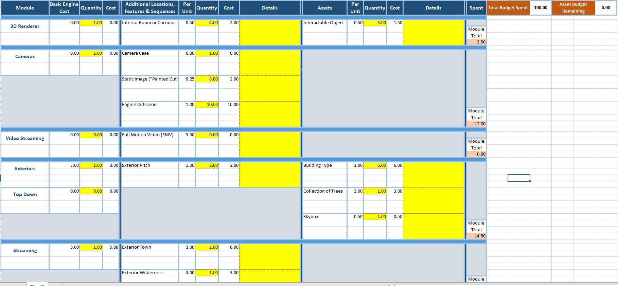

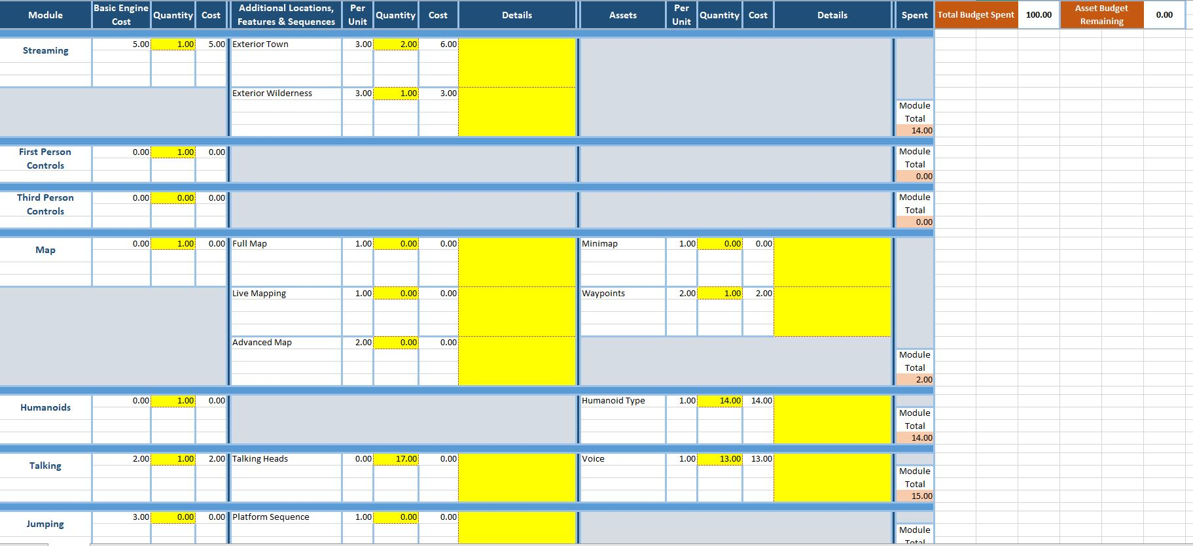
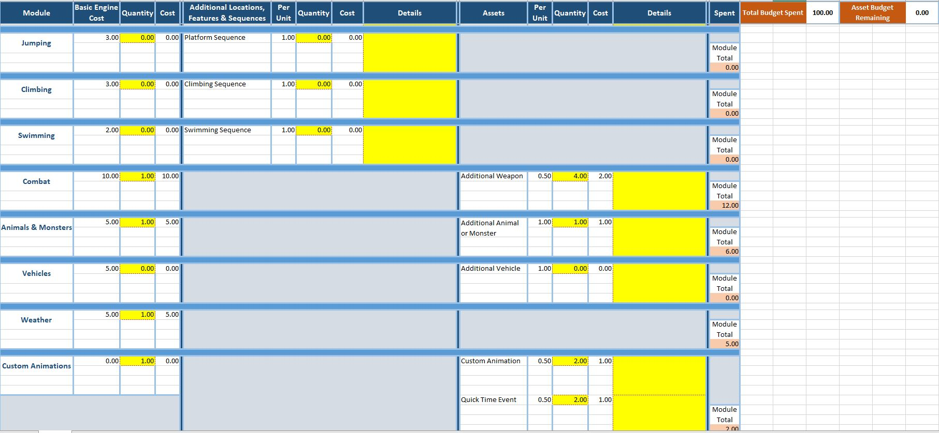

References
For Images Used in Project

References
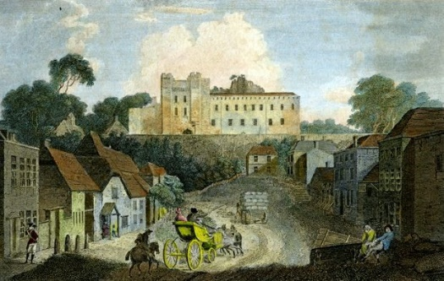
https://i.pinimg.com/originals/00/41/79/0041790cd84f4d322062b2591384c99a.jpg
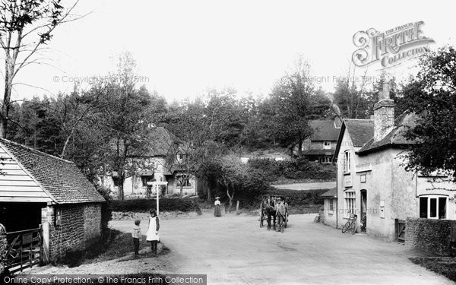
https://photos.francisfrith.com/frith/churt-post-office-1906_55512.jpg
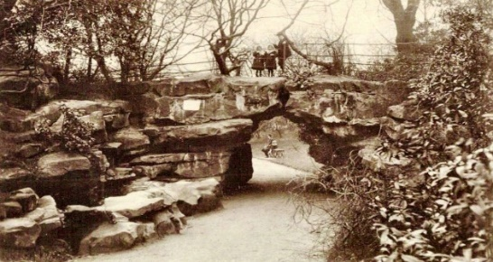
http://www.flickr.com/photos/rpsmithbarney/
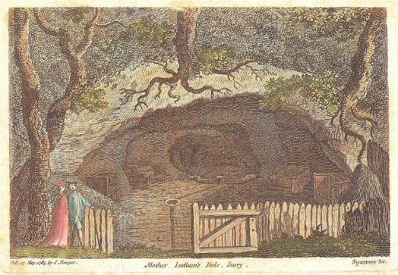
https://www.davidcastleton.net/wp-content/uploads/2020/08/Mother_Ludlams_Cave_1785-ps.jpg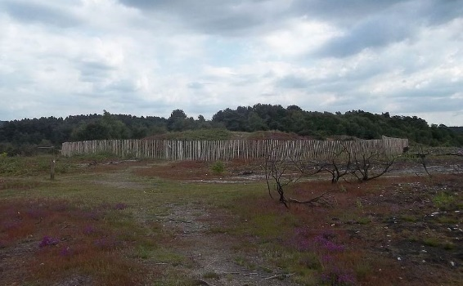
https://www.davidcastleton.net/wp-content/uploads/2020/08/Tumuli_on_Frensham_Common-ps.jpg
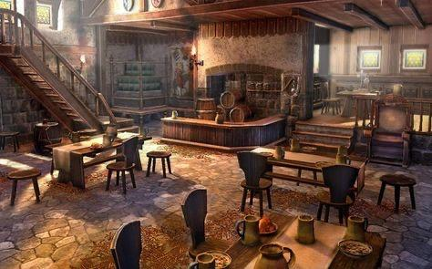
https://www.pinterest.co.uk/pin/846254586225108353/

